KV ACADEMY OF DANCE
REGISTRATION FORM

STUDENT NAME: ................................................................

DATE OF BIRTH: ................................... M/F ..............

AGE: .......................................

TIME OF CLASS ATTENDING: .....................

ADDRESS: ...........................................................................................................................

...............................................................................................................................................

HOME TEL: ............................................ MOBILE NO: .....................................................

EMAIL: ..................................................................................................................................

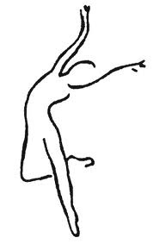
ANY ALLERGIES/SPECIAL NEEDS/ASTHMA OR OTHER CONDITIONS:

................................................................................................................................................

................................................................................................................................................

ANY BROKEN/FRACTURED BONES OR SERIOUS INJURIES:

................................................................................................................................................

................................................................................................................................................

PLEASE TICK IF YOU ARE HAPPY FOR NEWS & INFORMATION TO BE SENT VIA EMAIL: (If you tick YES your termly invoice will be sent via email.)

YES .......... NO ..........

Once completed please either post to 10 Selborne Gardens, Farnham, Surrey, GU9 8AE, hand to Miss Kimberley or email details directly to kvacademyofdance@yahoo.co.uk. MANY THANKS!

